**Group name:** Milestone

**Group members:** 1. Hasib Ahmad (F17040108)

1. MD Torikul Islam (F17040104)
2. Saif Haque (F17040102)
3. Zafar Iqbal (F17040119)
4. Shoaib Ahmed (F17040117)

**Project proposal:**

**Project name:** Online Delivery Service

**Online Delivery Service**

**Vision:** Our goal is to make a mobile application named “Online Delivery Service”. This will help connect the customers of the user of this software application in order to cooperate with the merchants of branded shops. The steps of registration is very easy, all that has to be done is to start with your name, phone number, email ID, and password. All customer’s information will be saved in the database and the customer will be able to see the saved data any time and edit it when they want. In order to do that a user must log in to the software by inputting corresponding valid data. The privacy of the customers will be kept confidential, but the application will need the access of customers location.

**Software architecture:** The premeditated language/tools that will be usedin our project are as below-

1. Language: JAVA
2. Toolkits:

JDK(Java Development Kit)

SDK(Software Development Kit)

Android Studio

ICO converter (to convert image into icon)

1. Mobile application development platform: Firebase for Database
2. 4. REST API

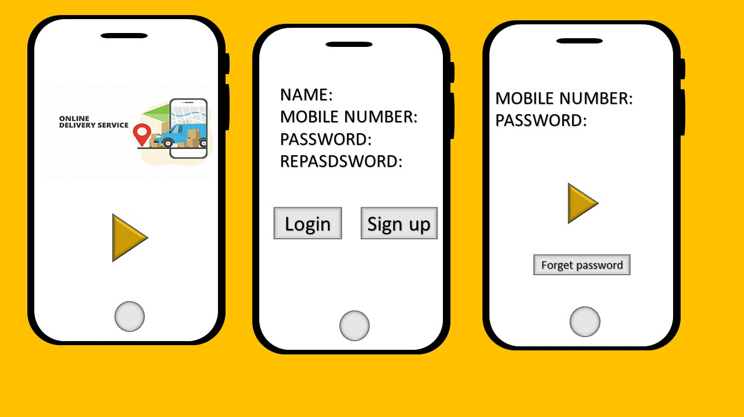**Software structure:** The key structure of our programmedsoftware is like this –

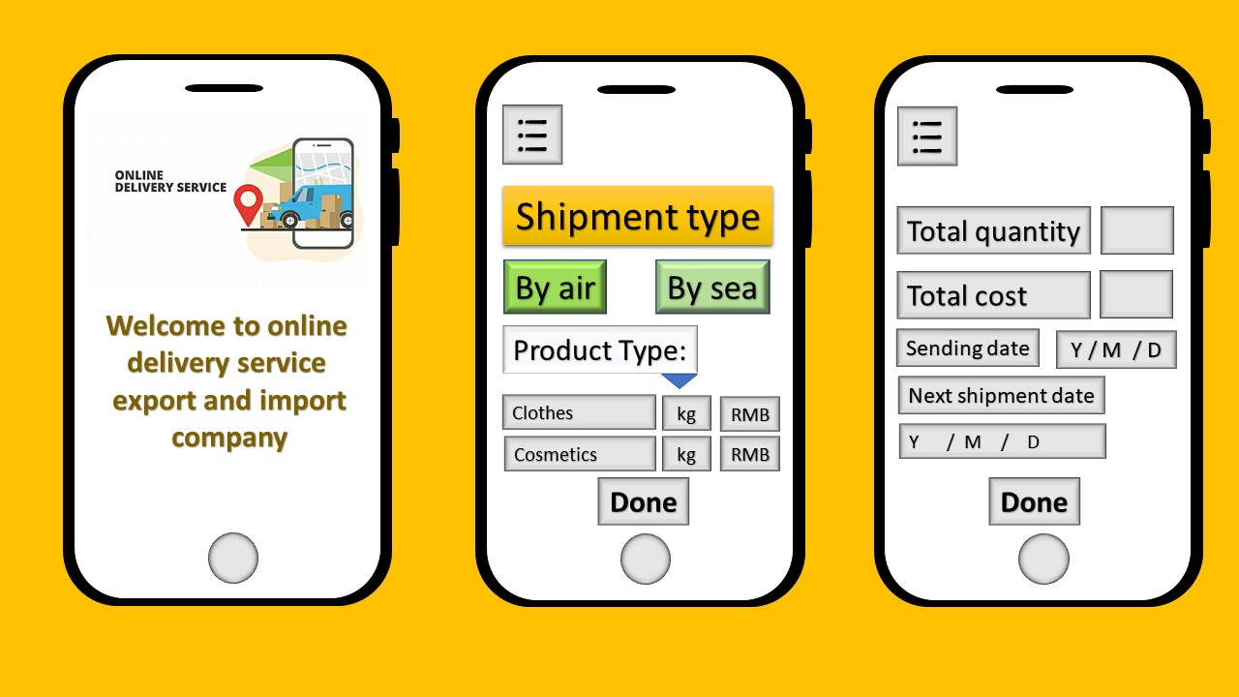

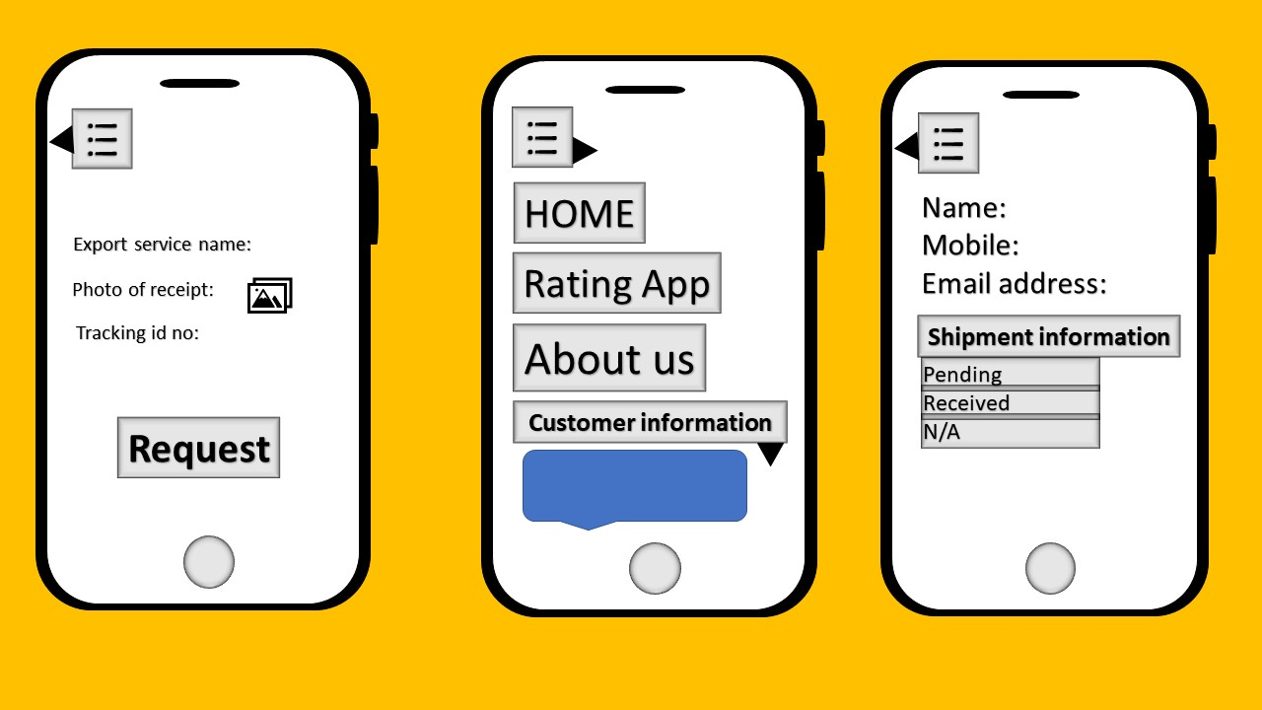

**Challenge and risks:** This project is our first time to develop an android application. It will be really difficult and definitely a challenging task to accomplish. The key challenge is to choose the goal of our project first and make it more valuable and worthy to develop a new tool to fulfill our goal. Each step of this project demands for instance, creation of all the options for data/information (name, mail, password, phone no etc.) by creating ‘code’ and making sure to run it smooth, will be the most technical part of this successful project. It is not easy to execute the task to complete it flawlessly. If the IDE field does not have JDK and JRE then we will not be able to run it properly. And it’s a must to say about the perfect code. If the code is done imperfect anyhow then it is quite impossible to finish within a given time, hence we just have to try work very hard on making this come to reality by hard and soul.